Business Name:
Proposal Development of Native Android Application









An ISO 9001:2015 Certified Company



§
ABOUT FITSER

Fitser is a web designing, developing as well as a software developing company which has been consistent in offering quality services. Primarily focusing over offering customized website designing and development, Fitser has also been offering its clients with customized and moderate packages which are capable of surpassing the expectations.
What we actually offer our clients includes:
Dexterous proficiency

Concentrate on customized web development

IT enabled services

Top notch software assistance

We have effectively taken care of more than 650 ventures serving more than 500 worldwide satisfied clients. We serve an excellent combination of experienced craftsmanship and knowledge in terms of web designing and development, internet marketing and mobile application development. Our work force consists of over 100 highly experienced, qualified and motivated software professionals who can take care of your business with utmost agility

SOLUTION TO IMPROVED BUSINESS

Version: | 3.0
Ownership: | Client
Prepared By: | Sanjay Sasmal  ‘Business Analyst’ Fitser
Date: | 24/10/2019



WE SPECIALIZE IN

1 WEB DESIGN AND DEVELOPMENT

WEB APPLICATION 2
3 MULTIMEDIA SOLUTIONS
GRAPHIC DESIGN 4
5 SOFTWARE APPLICATION
SEARCH ENGINE OPTIMIZATION 6
7 DESKTOP APPLICATION
E-COMMERCE SOLUTIONS 8

Contents
1. Introduction 5
1.1 Project Scope 5
1.2 Purpose: 5
1.3 Note: 5
2. Overview of the System 5
3. User Types and Their Functionality in the System 6
3.1 Users Functionalities: 6
3.1.1 Splash Screen: 6
3.1.2 Sign Up: 6
3.1.3 OTP Verification: 6
3.1.4 Update Profile: 6
3.1.5 Login: 7
3.1.6 Forgot Password: 7
3.1.7 Home Screen: 7
3.1.8 Café Details Screen: 7
3.1.9 Book Café Screen – Select Date Time: 7
3.1.10 Book Café Screen – Select Room: 8
3.1.11 Select Menu: 8
3.1.12 Menu Category Screen: 10
3.1.13 Specific Menu Item Screen: 10
3.1.14 Book a Seat: 10
3.1.15 Cart: 11
3.1.16 Apply Coupon Code: 11
3.1.17 Payment: 11
3.1.18 Membership: 12
3.1.19 Hamburger Menu: 12
3.1.20 The magnifying glass symbol 12
3.1.21 Bottom Navigation Menu 12
3.1.22 Update Email and Phone Number: 12
3.1.23 Upcoming Booking Status: 13
3.1.24 Past Booking History: 13
3.1.25 Information Pages: 13
3.1.26 Receive Push Notifications from the app 13
3.1.27 Receive Email Notifications: 13
3.1.28 View Ratings 13
3.1.29 Rate and Leave Review Screen: 13
3.1.30 Wallet: 13
3.1.31 Logout: 14
3.2 Admin Functionalities: 14
3.2.1 Admin Log in: 14
3.2.2 Admin Dashboard: 14
3.2.3 Manage Café: 14
3.2.4 Manage Rooms: 14
3.2.5 Movie Category Management: 15
3.2.6 Mange Movies Available: 15
3.2.7 Size Variants Master Management: 15
3.2.8 Food Item Category Management: 15
3.2.9 Food Item Sub-Category Management: 15
3.2.10 Food Item Management: 15
3.2.11 User Management: 17
3.2.12 View Booking Details: 17
3.2.13 Manage Availability for Rooms 17
3.2.14 Discount Coupon Management: 17
3.2.15 View Transaction Details: 17
3.2.16 WalletConfiguration: 18
3.2.17 Manage Membership Packages: 18
3.2.18 How to create Membership Packages: 18
3.2.19 Manage Testimonials/Reviews 18
3.2.20 Mange Reports: 18
3.2.21 Content Management System: 18
3.2.22 Manage Push Notifications: 18
3.2.23 Mange Newsletters: 18
3.2.24 Sub Admin Master: 19
4. External Interface Requirements 19
5. Client Deliverables: 19

Introduction

Project Scope
The Scope of the project is to design and develop native Android mobile app for a Café, in lines with Book My Show App, where users can book for private screening of movies and other shows from the library with add on for food and beverage from the menu. The users can choose from the flexible time slot for booking the facility. The development has to be from scratch with design and development of the apps and the admin. The development has to be scalable for an increase in the number of users.

The Client is looking for development of Android app and web admin dashboard which will facilitate the admin to manage the apps. The Administrator will be responsible for managing the data masters and the users from the App based backend panel.

Purpose:
The purpose of this document is to share an understanding and discuss the features and functionalities of the system in details. Each and every users and their functionalities are described in this document to reach an agreement with the client regarding the acceptability and confirmation of the features.

Note:
All Images used in the document are for reference and understanding purpose only. Pattern, Layout will be enhanced and can be changed during designing stage.

Overview of the System
- Easy navigation, intuitive & rich user friendly user interface
- Backed with high end CMS (content management system)
- Easy Signup Process for users
- Smart filters for Searching.
- Robust backend
- Backend, Admin Control Panel.

User Types and Their Functionality in the System
There will be 2 type of users associated with the system. The first one is the Customers, who will use the mobile app to book a room in cine café for certain duration to watch movies/Netflix/Disney-hotstart/amazon prime and enjoy some food/beverage and the other one is the system administrator, who will manage the app.

Users Functionalities:

Splash Screen:
- Splash screen, or very often called as the launch or boot screen is the first screen that is displayed when an application loads.
- It is the welcome screen of the mobile app that the users encounter while launching the application.

Sign Up:
- The Users of this app can download the apps from their respective device OS supported app stores, e.g. Google Playstore.
- The Users needs to provide the phone number.
- On submission of the mobile number an OTP will be sent to the user’s registered mobile number.
- User can provide the app permission to auto retrieve the OTP from their message inbox, or they can self input the OTP.
- Users can have only one account created under a mobile number.
- Every user will have a unique user id that cannot be duplicated by any other user. The username will be the user’s mobile number.

OTP Verification:
- While registration with mobile number the user will receive an OTP on their mobile phone for completion of verification for security purpose.
- Customer now needs to provide the OTP in the App on the OTP Code screen so that their phone number can get verified.
- Once the Phone number is verified after OTP verification the customer is redirected to the Update Profile screen on the App.

Update Profile:
- On the update profile screen, the user will need to update the following fields:
- First Name
- Last Name
- Email
- Gender
- Date of Birth
- Location
- Mobile Number
- Upload profile picture
- From the update profile screen once the user update all the information and submits the form, the details will be saved and the user will be redirected to the home screen.

Login:
- Customer can login to the apps after they logout from the Apps.
- The customers can login from this screen using their phone number and OTP that they receive on their registered mobile number.
- If the customer forgets their password, they can click on the “forgot password” to receive a link or code by e-mail, that can be used to reset the password.
- If any customer ends up in this screen by mistake and hasn’t set up an account. The customer can click on Register and they will be redirected to the Registration page.

Forgot Password:
- Customer will pass following steps to reset their password:
- Customer will provide user name/email (text field) to reset their password.
- After submitting info system will generate a verification link and send to email address to reset password.

Home Screen:
- After the user logs in to the app, he will be taken to the home screen.
- On the home screen, the user will get to see the available cafés.
- The café will be listed with the name and an image of the café. Also, the user will get to see the average rating received.
- Once the user click on the name / image of the café, the user will be taken to the next screen.
- There will be a bell icon showing active notification. Once the user will click on the notification link, the user will be redirected to the notification screen, where the user will get to see all the listed notifications.

Café Details Screen:
- On the café details screen, the user will get to see the following:
- Name of the café.
- Café Images.
- A small text description about the café.
- View café address
- Location on map
- Percentage of Rating received along with the total number of ratings
- View Reviews with count
- Button to Rate the café
- Button to Book Cafe

Book Café Screen – Select Date Time:
- From the café details screen at first the user needs to select the date and time when they want to book a room.
- On this screen the user will need to select the following:
- User needs to select the Date.
- User needs to select the Time
- Select Movie:
- In this screen, the user needs to select if they want to watch Movie, Netflix, Amazon Prime or Disney Hotstar.
- If user chooses to watch a movie then the duration for booking the room minimum will be 3 hours. If the duration of booking the room is below 3 hours it will be set atleast 3 hours. If it is above 3 hours then no changes will be done.
- In this screen, the user will be able to view the list of movies available category-wise.
- Each movie will be displayed by the movie name and the movie poster image.
- For the different categories, the user will get to see 5-6 movies with a button for view more.
- If the user clicks on the View more button, then the user will be taken to a page, where the user will get to see all the movies listed under the category. The user can select the movie, which he/she wants to view from the list.
- Else there will be a search option on the page, the user can search using the search option.
- If the searched movie is available, then the user can select that movie. If the movie is not available, the user will be asked to select from the available list of movies.
- Total no of hours
- No. of people attending the screening
- After providing the preferred date and time, the user will need to check for the availability.
- User will find the rooms in the Café available as per the availability criteria set by the User.
- If the room is not available, then the user will be notified and the user will be requested to select any other time slot. The time slots will be divided into 30 minutes padding time (buffer time).
- However, for the selected date and time if any room is available then the user will be redirected to the next screen which is for selecting room.

Book Café Screen – Select Room:
- In this screen the user will be able to view all the available rooms in the café.
- All the rooms will be listed by an image of the room along with the room name, screen size and available seating capacity.
- The user will need to select one room from the list to proceed further.

Select Menu:
- In this screen the user will be able to select the food and beverages menu.
- This is an optional area.
- User can select for veg menu only.
- On this screen, the user will get to see the main menu categories like:
- Trending
- Pasta
- Starters
- Classic Pizza
- Mains
- Salads
- Desserts
- Drinks
- Combos
- All the menu categories will be listed with an image and the name of the category.
- Once the user clicks on any category, the user will be taken to the specific page for the category.

Menu Category Screen:
- On the menu category screen all the menus under the respective category will be listed on the screen along with the price and ingredients for the menu item. For example, if the user clicks on the Menu for Vegetarian Pizza, then on the Menu category page the user will get to see all the menu items available under the Vegetarian Pizza category. For example:
- Fungi Portobello
- Anti-Pasto
- Pesto Bianco

Specific Menu Item Screen:
- From the menu category screen, once the user will click on any of the specific menu item, the user will be redirected to the specific menu item screen.
- On the specific menu item screen, the user will get to see all the details for the menu like:
- Menu Name
- Image of the menu
- Description
- Ingredients
- Menu price
- Some of these menu items can have some size variants and some of the menu items may not have the size variant. For example, all the pizza items will have different size variants. So if the user clicks pizza then the user will get to see the size variants available under the menu item. The different size variants can be:
- Large
- Medium
- Small
- So for the products, which have the size variants, to order for those menu items with the size variant, the user will first need to select the size variants.
- User can also select toppings or add ons with their pizza and then be able to add the product to the cart.
- If the product does not have any size variant, then the user can add the product to the shopping cart directly from the menu item screen.

Cart:
- Menu items added to the cart will be available in the cart screen.
- The cart screen will be divided in to 2 parts. On the top part of the cart page, the user will get to see the venue booking details and the bottom part of the cart page, the food order details will be shown.
- The food order section on the cart page will be incremented by one unit when the user orders any item from the App.
- On clicking cart icon, the system will redirect to the cart tab with column for:
- Item Description
- Quantity
- Price
- Sub Total
- Duration of booking (This is no. of hours)
- Membership Discount if applicable
- GST (Food 5%)
- Total
- There will be a positive (+) and Negative (-) sign available with the quantity that will increase or decrease the quantity of the item to be ordered.
- From the cart page, the user can click on the Pay Now button in order to complete the order. Also there will be a Continue shopping button, which will allow users to redirect back to the menu screen.

Apply Coupon Code:
- On the cart page, there will be an option for the user to apply the discount coupon code for non members.
- Members will automatically receive a discount depending on the type of their account.
- Members cannot add any discount coupon code on top of the discount they are receiving as a member
- If the discount coupon code is a valid one, then the user will get the discount allotted for the discount coupon and the final order charge will be updated accordingly.

Payment:
- From the cart page the user can proceed to make the payment. If the user clicks on the option for proceed to payment, the user will be taken to the page for the payment.
- Customer can use his/her credit card, debit card for making the payment.
- Customer will also have the option to pay using UPI or using the balance available in their in-app wallet.
- If wallet don’t have sufficient amount rest amount need to be paid using their credit/debit card or UPI.
- After the successful payment, the user will get to see a thank you message and the user will be able to view the booking details and the order details in the section for upcoming Booking section in the app.

Membership:
- Customer can become a member.
- On the Membership page Customer can find a list of membership subscription and their monthly charges and yearly charge.
- On different subscription package businesses will get different type of discounts.
- Customer needs to select the subscription plan along with the duration.
- Payment:
- Customer can use his/her credit card, debit card for making the payment.
- Customer will also have the option to pay using UPI or using the balance available in their in-app wallet.
- If wallet don’t have sufficient amount rest amount need to be paid using their credit/debit card or UPI.
- After the successful payment, the user will get to see a thank you message and the user will be able to view the booking details and the order details in the section for upcoming Booking section in the app.

Hamburger Menu:
- The hamburger menu or hamburger icon is a name given to the menu icon found in apps that hides the traditional menu. Alternatively referred to as the three-line menu or menu button.
- Using the hamburger menu makes it easier to view program options on mobile devices. The following options will be available under the hamburger Menu:
- Update Email ID and Phone Number
- Membership
- Upcoming Booking Status
- Past Booking History
- Wallet
- Information pages such as About us, FAQ, Privacy Policy, Terms & Conditions
- Logout

The magnifying glass symbol
- The magnifying glass symbol is important as a user will immediately be able to identify it as a sign for the search field.

Bottom Navigation Menu
- Bottom navigation bars display three to five destinations at the bottom of a screen. Each destination is represented by an icon and an optional text label. When a bottom navigation icon is tapped, the user is taken to the top-level navigation destination associated with that icon.

Update Email and Phone Number:
- When the user selects for this option, the user will need to provide the updated email and phone number. Then an automatic email with a verification code will be sent to the registered email id of the user.
- The user will need to provide the verification code in the verification screen to update the registered email id or phone number.
- For mobile number validation an OTP SMS will be sent. The user will need to validate the OTP in order to change the phone number.

Upcoming Booking Status:
- Here the user will get to see the complete booking details with the date and time for booking, room booked, for number of people, movie selected, foods selected.

Past Booking History:
- In this section, the user will get to see the list of all the past orders.
- Once the user will click on any of the past order list, then user will be taken to the order details page, where the user will get to see the details for that specific past order like the date and time for booking, room booked, for number of people, movie selected, foods selected.
- User can repeat their last order.

Information Pages:
- These will be basically information pages which will provide information about the company, how it works, terms & conditions

Receive Push Notifications from the app
- The user will receive various push notifications for any change in the Order status.
- The user will receive Push Notification for any admin messages.

Receive Email Notifications:
- The user will receive email notifications for the Order Details on the order delivery.
- The user will receive email notification for any admin email newsletters.

View Ratings
- If the user clicks on the Percentage of Rating received along with the total number of ratings from the home screen or the café details screen, the user will be redirected to the next screen, where the user will get to see the user-wise ratings and reviews given by all the users.
- On this screen the user will get to see the button to rate and leave review for the café.

Rate and Leave Review Screen:
- In this screen the user will be able to rate and leave review for the café.
- For rating, the user will get to rate the café on a scale of 100 points using a drag gable scrollbar.
- For review, the user will get a text box to submit the review.
- On submission, the review will be in queue for admin moderation. Once the admin approves the review, the review will be published on the app.

Wallet:
- In this section user will find their wallet balance
- User can recharge their wallet balance using their Credit or debit card.

Logout:
- Once the user will click on this option, the user will be logged out of the app.

Admin Functionalities:
The Administrator will be the controller of the apps. They will be able to perform the following tasks:

Admin Log in:
- Admin log in using Secure User ID and Password

Admin Dashboard:
- Admin use dashboard to manage the apps from User Management, Item Management to generation of Reports.
- On the dashboard the user will get to see the list of the latest booking received.
- On the dashboard, the user will be able to see the total number of:
- Cafe
- Customers
- Total number of booking
- Total Sales for food menu
- Total Food Categories
- Total Food Sub-categories
- Total Food Items

Manage Café:
- From this section the admin will be able to add/edit/delete café.
- From this section, the admin will be able to mark the available café as Active/Inactive. Inactive café will not appear on the app.
- To add a new café the admin will need to provide the following:
- Café name
- Upload café images
- Description
- Café address

Manage Rooms:
- From this section the admin will be able to add/edit/delete screen rooms available in the café.
- From this section, the admin will be able to mark the available rooms as Active/Inactive. Inactive rooms will not appear on the app.
- To add a new room, the admin will need to provide the following:
- Room name
- Upload room images
- Description
- Facilities available
- Screen size
- Seating capacity in the room

Movie Category Management:
- From this section the admin will be able to add/edit/delete movie categories available.
- From this section, the admin will be able to mark the available movie categories as Active/Inactive. Inactive movie category will not appear on the app.

Mange Movies Available:
- From this section the admin will be able to add/edit/delete movies available in the library.
- From this section, the admin will be able to mark the available movie as Active/Inactive. Inactive movie will not appear on the app.
- To add a new movie, the admin will need to provide the following:
- Movie name
- Upload Movie poster image
- Select Category

Size Variants Master Management:
- The Admin will be able to add/edit/delete size variables for the food items
- Mark size variables as Active/Inactive

Food Item Category Management:
- The Admin will be able to add/edit/delete item categories
- Mark categories as Active/Inactive

Food Item Sub-Category Management:
- The Admin will be able to add/edit/delete item sub-categories
- Mark sub-categories as Active/Inactive

Food Item Management:
- The Admin will be able to add/edit/delete food items in the app
- Mark food items as Active/Inactive
- In order to add a food item, the user will need to provide the following:
- Item Name
- Description
- Ingredients
- Image
- Price
- Mark the item as Trending
- Whether the item has any size variant: Yes / No
- If any size variant is available, then select the size variables from the size variant master and provide amount for the selected size variant

- Select Add-ons:
- Admin can select the options which will be available as Addons.
- Admin needs to set the price for each selected Addons.

- Advanced:
- Featured Item: Set the item as featured item to be displayed on the website’s home page.
- Admin needs to add the image of the as featured item.
- Admin can create a Combo by adding extra items like Coke with Pizza to make it a combo and add price for extra item to be included from the inventory or add a combo price.

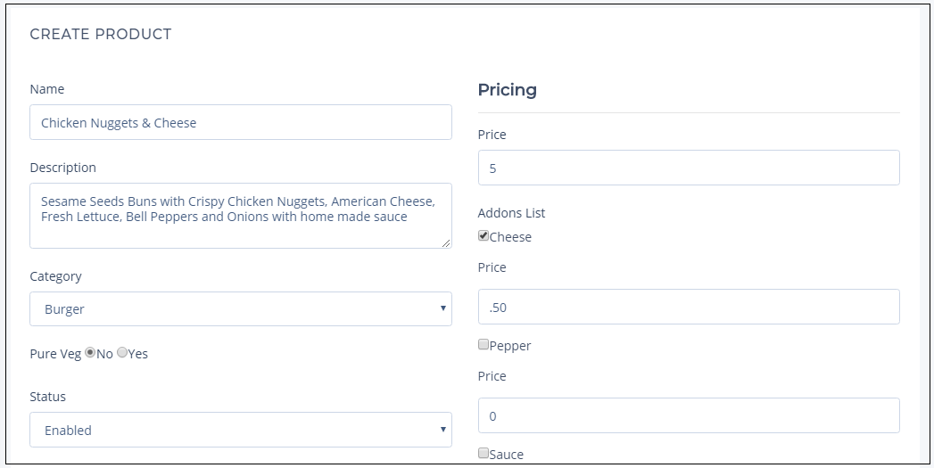

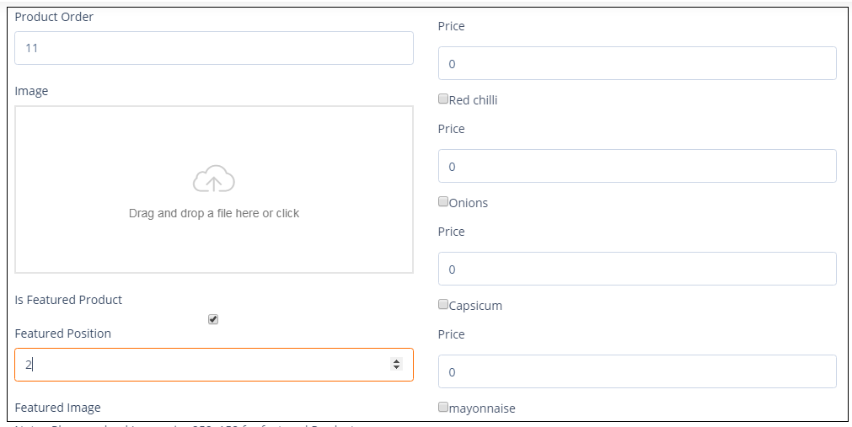

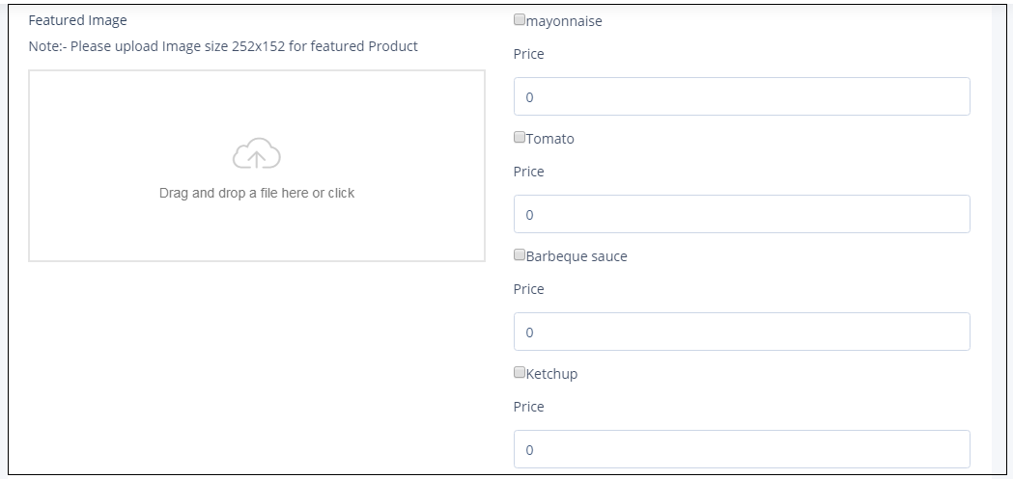

User Management:
- The admin will be able to view the registered user details.
- Mark the user as Active / Inactive.

View Booking Details:
- The admin will be able to view the details for all the booking received from the Dashboard or from the Booking Management Section.

Manage Availability for Rooms
- From this section, the admin will be able to manage the availability of the rooms.
- If any room is booked from any other sources, then the admin will be able to manage the availability of the room from this section.
- If any room is marked as unavailable for any specific date and time, then the room will not be available in the searches during that time.

Discount Coupon Management:
- The admin will be able to create discount coupons and share that with the users.
- To create a discount coupon, the admin will need to provide the following
- Discount Name
- Amount / Percentage of discount
- Amount or Percentage Amount
- Coupon Valid From Date
- Coupon Valid To Date
- Maximum no. of users can use the coupon
- Number of time any user can use the coupon

View Transaction Details:
- In this section, the user will get to see details for all the transactions for all the booking.
- The admin will be able to use filter the list by date range, by user

Wallet Configuration:
- Admin can set Coin To Cash Rate: Example: 1000 * 0.01 = $ 10 USD
- Admin can set Refund Rate (%)
- Admin can allow Partial Payments from wallet.
- Admin can disable all the other payment methods if there is enough funds in the wallet:
- Admin can force users to checkout using the wallet if there is enough funds in it.
- In menu balance settings:
- Show Wallet Balance in The Primary Menu
- Show the balance to the right of the menu
- Custom deposit amounts:
- Allow the customer to enter a custom deposit amount instead of selecting one of the pre-made values:
- Minimum deposit:

Wallet:
- Admin can find total balance in each users wallet.
- Admin can add balance in user wallet

Manage Membership Packages:
- Admin can create new Membership Package from the Manage Membership Packages section.
- Admin can edit/delete existing Membership package from the Manage Membership Packages section.
- Admin can find all the existing Membership Packages in a list.

How to create Membership Packages:
- Admin at first needs to provide a title for the Membership Packages.
- Now admin needs to provide a description about the Membership Packages.
- Admin needs to set the monthly and yearly price of the package.
- Admin can initiate a sale while creating the subscription plan.
- Admin need to mention the sale start and end date.
- Admin for each plan need to select which features will be included, e.g. discount per complete order.
- Admin need to submit to create the plan.

Manage Testimonials/Reviews
- Admin can find all the Testimonials/Reviews submitted in the Manage Testimonials page.
- Admin click on the Testimonial ID/ Reviews ID and they will be redirected to the Testimonials/Review Information details page.
- Admin now can find the content and images submitted by the Business as their testimonial along with the star ratings.
- Admin can approve or reject a Testimonial submitted.

Mange Reports:
- The administrator will be able to generate and download reports with different combinations.

Content Management System:
- In this section, the admin will be able to manage the text, images and embedded videos on the general static content screens such as the about us, privacy policy, terms and conditions, etc.

Manage Push Notifications:
- From this section, the admin will be able to send customized push notifications to all the users or the admin can select some users and send them push notifications

Mange Newsletters:
- From this section, the admin will be able to send customized email newsletters to all the users or the admin can select some users and send them email newsletters.

Sub Admin Master:
- Admin can add Sub Admin from Sub Admin Master Page.
- Admin can edit/delete Sub Admin from Sub Admin Master Page
- Admin can set Sub Admin account active/inactive from Sub Admin Master Page
- Admin can Enable/Disable Automatically generate password.

External Interface Requirements

- Hardware Interfaces:
- Ability to exchange data over network
- Continuous Power Supply
- Ability to connect to network
- Ability to access File Manager/Gallery

- Software Interfaces: The software interface is specific to the target users’ device software systems.

- API/SDK Required:
- Payment gateway API
- SMS gateway API
- Google MAP API
- Mailchimp API
- UPI gateway API

Client Deliverables:
- Logo
- Domain User ID and Password to upload files after completion of work and testing
- Server Details to transfer the files on the server
- Google Playstore and Apple App Store Account Credentials to publish the apps
- Payment gateway details
- SMS gateway details


PROJECT PLATFORM

APP design- Graphics [PSD/Sketch]

Android version of the APP – Java/Kotlin Programming Language.

Web Admin Framework: PHP

We will provide you with full featured and secured admin control panel where you can have access to his dashboard to control the APP.
SECURED ADMINISTRATIVE PANEL (BACKEND LOGIN)

OUR DEVELOPMENT PROCESS IS BROADLY DIVIDED INTO THE FOLLOWING SIX PHASES:

Visualization  Conceptualization |  | Functional  Speciﬁcations |  | System Architecture and Design Development
Delivery and Deployment |  | Testing  and Quality Assurance |  | Integration

PHASE WISE PAYMENT STRUCTURE

Approx. Cost Estimation:
Total cost for designing & developing the native App:

Timeline:
Business Days after approval of the 1st Stage

Payment Terms:

MILESTONE I
Visualization Conceptualization(wireframe and UI design) | $
MILESTONE II
System Architecture and Design Development (AI design and development) |  | $
MILESTONE III
Functional Specification Stage (Programming) |  |  | $
MILESTONE IV
Testing and Quality Assurance & Delivery and Deployment (job completion) |  |  |  | $

JOIN US

OUR PRESENCE
SALES/SUPPORT HOTLINE

INDIA
HEAD QUARTER
#1307, 13th Floor, Tower 2, Godrej Waterside, DP Block, Sector V, Saltlake, Kolkata-700091, West Bengal, India
AUS: +61 (280) 113465
USA: +1 (360) 5383135
CAN: +1 (438) 7949227
UK: +44 (121) 794 4897
ROM: +40 (745) 348 765
IND: +91 (033) 4062 4483

ODC
Candor Tech pace, Ground Floor, Tower A1, IT SEZ, Action Area 1D, Block No DH, New Town, Rajarhat, Kolkata-700156

UNITED KINGDOM
OFFICE: 1
2 Bridge Avenue, Maidenhead,
Berkshire SL6 1RR
United Kingdom

JOIN OUR NETWORK
/company/ﬁtser
/FitserNews
/FitserNews
marketing.met


OFFICE: 2
Crown House, 04th Floor,
Suite 400, North Circular Road
London NW10 7PN,
United Kingdom
Tel: 44 208 902 7000
Fax: 44 844 412 7723

Australia
Digital Fitser
24 Graham Road,
Clayton South

Panama

UK

Nigeria

Romania

Philippines

Clayton South

Vic-3169, Australia Clients & Partner Locations

